

**Did you know?**

**The Crosby Arboretum VOLUNTEERS**

**Receive *10% off***

**Gift Shop purchases?!**

VOLUNTEERS

with the most hours receive

***THANK YOU gift!***

Volunteer Service Hours

totaled at the end of the year.

VOLUNTEERS with the **three** highest number of service hours will **receive an annual Membership to The Crosby Arboretum**. Volunteers may choose an individual or family membership as their “thank you” for service.

Winners will be announced at the December Volunteer Meeting “Decorating for Open House”, the Friday before Open House.

Perks!

## 

**Ph 601-799-2311 Fx 601-799-2372**

**370 Ridge Road Picayune, MS 39466**

**www.crosbyarboretum.msstate.edu**

WWW.WEBADDRESS.COM

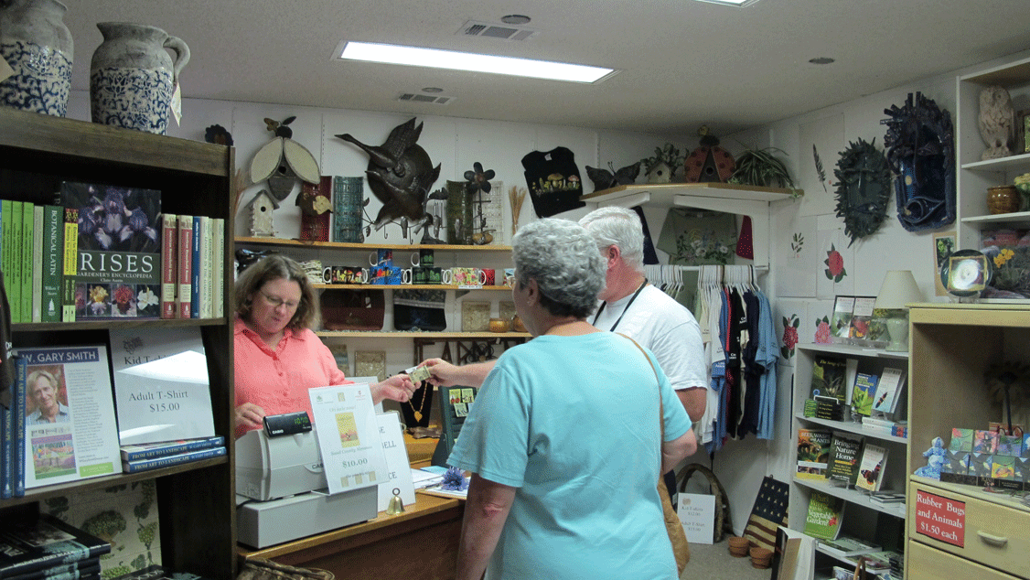

VOLUNTEER

Not a volunteer? Sign up today! Volunteer applications in the program room, online, or ask Jill Mirkovich.